LANDS END TO JOHN O’GROATS FOR SMA UK
24 May – 3 June 2023

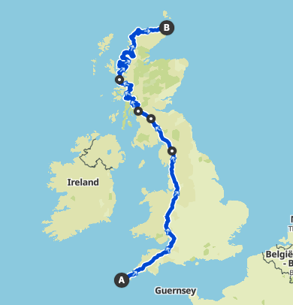

Gregor’s dad, Ian, our stand in scorer and regular spectator, along with two other guys who should know better are going on an adventure. They are attempting to ride from Lands End to John O’Groats, via Helensburgh, Applecross and the NC500 (because straight up isn’t far enough!).

Total Distance: 1190 miles / 1916 km
Climbing: 67,670 ft / 20600 m
11 Days in the saddle (c110 miles/day)
Combined age 167
They are fundraising for SMA UK which supports people and families affected by a rare genetic disorder, SMA UK to which we have a personal link; Ian and Jane lost their son Ben to Type 1 SMA 25 years ago.
Spinal Muscular Atrophy (SMA) is a rare, genetic, neuromuscular condition. It causes progressive muscle weakness and loss of movement due to muscle wasting (atrophy). Babies who have its most severe form (Type 1) will start to show symptoms around 2-4 months and usually do not make it to their first birthday.
You can see the route in more detail and follow their progress on the website (QR Code), or follow us on Facebook at 'LEJOG for SMA'.
Supported by: Helensburgh Cycles

